Premium Texts

Seal of Njaga - 42 gems/month



As the chosen bearer of the Seal of the legendary Drakaina Njaga, you shall be granted entry to the entirety of the mystical realm of Morkahja. But beware, for this privilege comes at a cost. To obtain this rarity, you must offer up 42 precious red yellow gems. And remember, it will only remain in your possession if you continue to make this sacrifice every lunar cycle.
Yet, the rewards are boundless. With the Seal, you will gain unfettered rewards.
- Unlock all portraits and frames, eliminating all costs entirely.
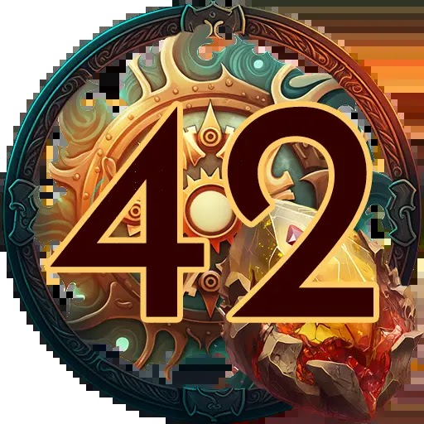
When activated, this buttons
opacity changes to 50% and
the end-date of the lunar
cycle appears, informing the
player that it automatically
renews if the gems
necessary are available

Seal of Norghor - 67 gems/month


As the chosen one to hold the Seal of the mighty Dragon Norghor, you shall be granted passage into the vast and mystical realm of Morkahja. But do not think this boon comes without a price. To attain this priceless artefact, you must part with 66 precious gems. And remember, to keep the Seal in your possession, you must offer up an equal sum every moon cycle.
The rewards shall be beyond your wildest dreams. With the Seal of Norghor in hand, you shall gain unhindered freedom.
- Unlock access to all expansions and rare encounters in Morkahja.
No longer will you be held back by the restrictions of mere mortals, for you shall have become something far greater.
